**INTRODUCTION TO CHATTING APP PROJECT**

Chatting app is an online system created for the community of people to interact with one another on the Internet. This system provides solution to most of the shortcoming of the traditional system .The system preserves a great amount of time and effort too for both.

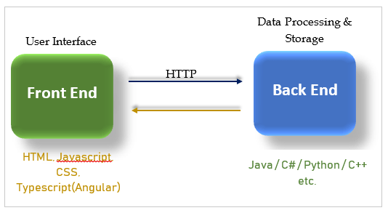

There are two sides first is client side and second is server side. In client side we have front end and server side we have back end. In front end we generally use HTML, Javascript, CSS. In this project I have used HTML and Javascript for front end and python for back end.